 **ASCOM Telescope Utility** 

**Nate McBee – Analytical Graphics Inc.**

**August 4, 2012**

This utility is used as an example for integration between AGI’s Systems Tool Kit (STK) and third party applications such as the **AS**tronomy **C**ommon **O**bject **M**odel (ASCOM). This utility will allow users to take advantage of STK’s system modeling capability by creating satellites, or other celestial orbiting bodies, and determine pointing geometry to specified geographic locations on the ground by using STK’s ability to model ‘Facility’ locations and advanced propagation algorithms to create orbiting bodies.

The following instructions are meant as a guide to using the utility. Assuming that a user is already familiar with STK, a scenario should be created with a Facility object used to designate a telescope’s geographic location (Lat/Lon/Alt) on the globe) as well as a Satellite object to be tracked by the telescope. See the below figure to see the STK setup.

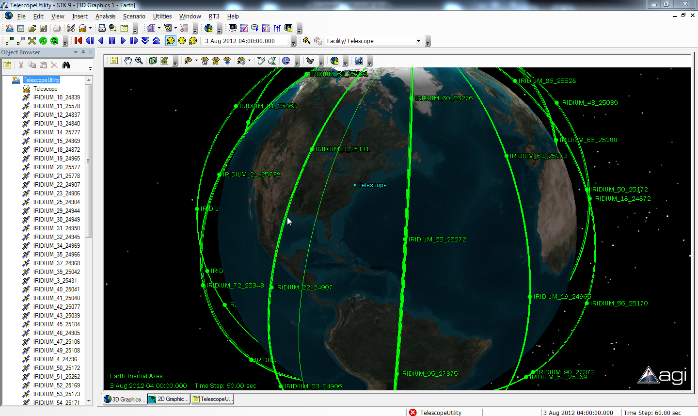

**Figure 1. Example STK Setup**

Figure 1 shows a typical STK Scenario setup with a Facility object and several Satellite objects. A similar STK Scenario should be used with this particular utility.

The ASCOM Utility should be launched and will look like the following screen shot:

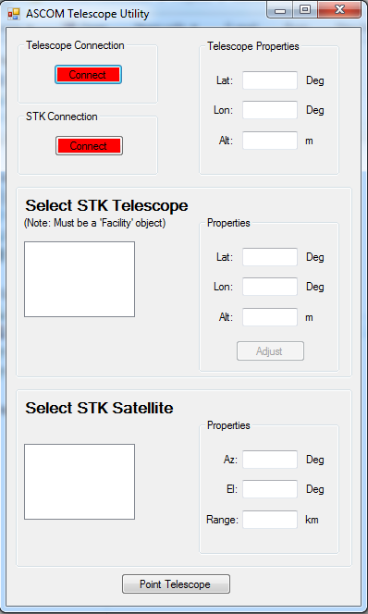

**Figure 2. ASCOM Utility**

You will first want to click the ‘Connect’ button for the Telescope Connection. This will launch the ASCOM Chooser which will allow you to connect to any existing Telescope driver you may have on your machine, or alternatively you can choose to use the ASCOM Telescope Simulator which comes with the ASCOM software.

For this example I am choosing to use the Telescope Simulator by selecting it from the Chooser pop up menu as seen here:

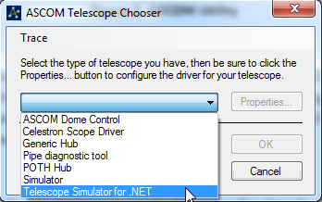

**Figure 3. ASCOM Telescope Chooser**

This will allow me to set properties for the simulated telescope if necessary such as the mount type, location of the telescope, slew rates, etc. I can select OK to launch the simulator as seen here:

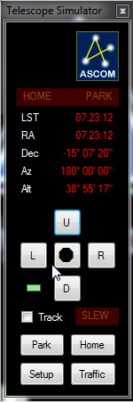

**Figure 4. ASCOM Telescope Simulator**

Now that the simulator is running, you can select ‘Connect’ to connect to the running instance of STK and import the objects that are available in the scenario.

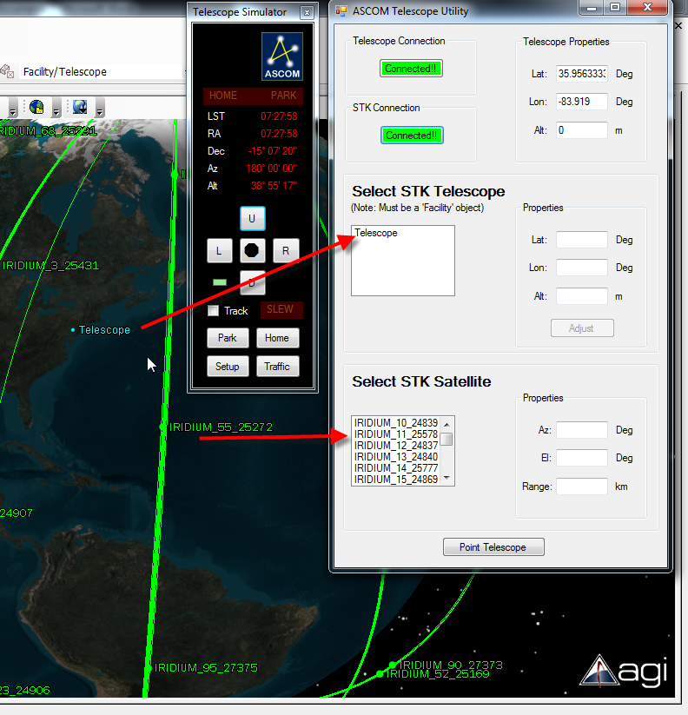

**Figure 5. ASCOM Telescope Utility Connected**

At this point a user can select the Facility object to be used in STK to gather the targeted pointing requirements from. (NOTE: Be sure that the STK Facility and the simulated telescope are in the same geographic location. If they are not, you can copy the simulated telescope’s coordinates and paste them into the STK Telescope properties and select ‘Adjust’ to move the STK Facility to the correct location)

Once the facility is selected and any adjustments have been made, you can select the Satellite object from the list that you want the telescope to “track” and select the ‘Point Telescope’ button.

You should see the Telescope Simulator start to slew to the object and continue to slew to maintain tracking of the object until it is no longer visible (i.e. No Access is reported from STK). If ‘No Access’ is reported, the Telescope Simulator will go to a specified ‘Park’ location and sit until Access is found at which time it will slew to the target and continue to track it.

Note: If you are curious to see the slew commands being sent to the Simulator, you can choose to open the ‘Traffic’ in the Simulator and view the ‘Slew’ messages that are being sent to the Simulator. This can be helpful to ensure that the communication is happening between the Utility program and the Simulator.

A video of this utility being used is uploaded to my Youtube channel and can be found here: <http://www.youtube.com/watch?v=VOfa5BtFWW0>